IEC Diamond Vision Map ( Aakash Savant )

Vision Map

Name: Aakash Savant

Year: 2026

Aakash Savant 2026 ( Goals )

2026 Goals (1-Year)

Business Goals
- Make ₹55,00,000 in profit and ₹90,00,000 in revenue. (The main source of revenue is from expensive consulting and retainers. No reliance on SaaS.)
- Obtain 30 clients for your core workflow and ERP problem-solving product by 2026.
(Not early-stage chaos, but mid-sized companies with actual budgets.)
- Obtain 12 clients for expensive consulting and advisory services by 2026. (₹2–5L for each engagement plus monthly retainers)
- Obtain 12 clients for expensive consulting and advisory services by 2026.(₹2–5L for each engagement plus monthly retainers)
- Produce 1,600 qualified leads with an overall 12–15% close rate.(Leads split across LinkedIn, Instagram, referrals, and direct outreach.)
- Learn and deeply sharpen 4 core skills:
- Sales conversations & objection handling
- Offer positioning & pricing
- Systems thinking for operations-heavy businesses
- Content clarity (authority writing + video thinking)
Hire 2 people:
- 1 delivery engineer (implementation + support)
- 1 ops/content assistant (tracking, follow-ups, content ops) (if possible, we can use AI tools to replace it).
- Build systems so product/service delivery quality improves by 3× (Documented workflows, reusable templates, predictable timelines.)

Brand & Distribution Goals
  - By the end of 2026, gain 100,000 social media followers.
  - (Not noise that goes viral. Audience (founder + operator)
  - Make a name for yourself by "fixing broken business workflows and execution systems before companies scale or automate."

Personal Finance Goals
- By the end of 2026, have ₹15,00,000 in cash in the HDFC bank account that ends in 131.
- Invest ₹3,000,000 in self-improvement and education (books, tools, mentorships, and learning resources that directly increase earning capacity).
- Invest ₹12,00,000 in long-term investments and mutual funds (SIP-driven, disciplined, no speculation).

Fitness/Health/Mindset Goals
- Reduce 10 kg of body weight and maintain 75 kg consistently.
- Whenever I get a chance, I work out.
- Eat X amount of calories daily.
- Practice mindset discipline daily
- Read 2 books per month

Relationship Goals
- Have lunch and dinner with family regularly
(minimum 5 days a week, no phone, no work).
- Take one international trip with family in 2026
(planned, not rushed, fully present).
- Gift an iPad to my elder brother in 2026

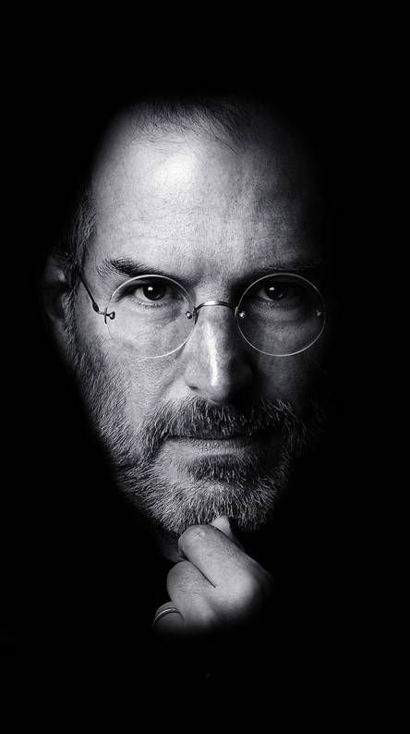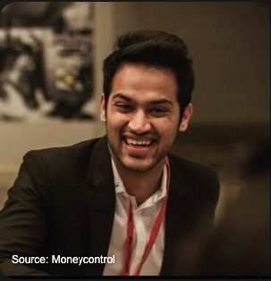
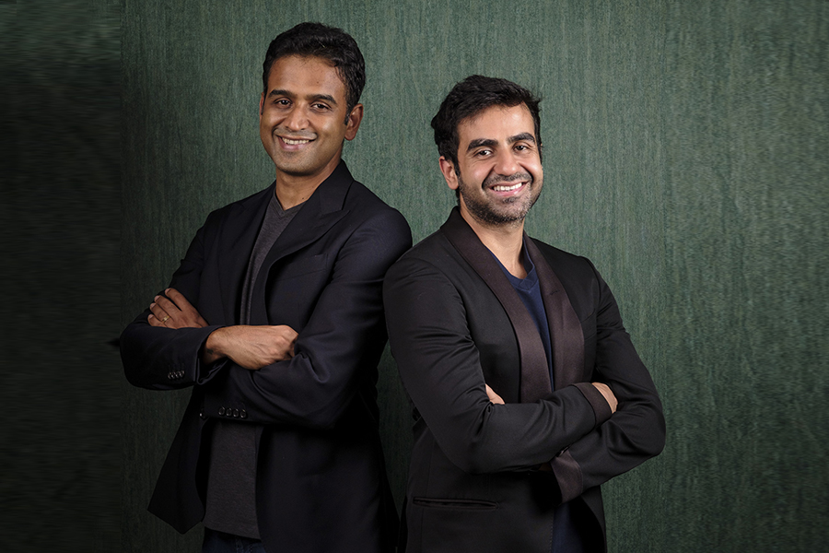

Aakash Savant 2026 ( Why - Conviction )

🟥Business - why should I do business, Not something else?
A job restricts my leverage, which is why I do business.

I carry out someone else's decisions at work.
I create systems, make choices, and oversee results in a business.

Business enables me to compound:

My thoughts

My execution

My personal experience

My evaluation should not be based on the number of hours worked or the number of approvals obtained.
I want to be judged on the value I create and the problems I solve.

I have long-term control over my life, autonomy, and rapid learning through business.

🟥Health/Fitness - why is having a healthy physique and lifestyle important for me?

Because without physical capacity, nothing I desire is possible.

→ Ill health diminishes:

→concentrate

→discipline

→Emotional regulation

→consistency in execution

→I don't practice aesthetics.

→I train to be able to work long hours, think clearly, sleep better, and maintain my composure under pressure.

→A strong mind is supported by a strong body.

→Every other objective becomes brittle in the absence of health.

🟥Financial—Why do I need to achieve my financial goals? Why is it important?
→Time, choices, and less stress are all purchased with money.
→Being financially secure enables me to:
- Consider the long term
- Take measured chances
- provide for my family without worrying
- Refuse unsuitable opportunities
→Money is not what I want for status.
→ I want money, so I make decisions based on reason rather than fear.
→Financial independence does not equate to excess.
→It's space for breathing.

🟥Social - why is having meaningful relationships with other humans important?

Since judgment is distorted by isolation.

Good relationships help me stay:

rooted in controlled emotions

Reputable

Family provides security.

A few people you can trust offer insight.

No amount of achievement can make up for damaged relationships.

Without a connection, progress eventually feels meaningless.

🟥Let’s say I achieve everything, then what’s my why?

My responsibility grows if I accomplish everything.

My "why" then turns into:

→Assisting others in avoiding preventable errors

→constructing systems that will outlive me

→ Instead of using hype, share clarity.

→ Money or titles are not what I want to be remembered for.

→I want to be known for my impact, clarity, and integrity.

→ The finish line is not success.

→It's the platform.

Aakash savant 2026 ( Skills - How )

Skills No 1 =Sales & Deal-Making
- Discovery calls, objection handling, closing high-ticket consulting, pricing confidence

Skills No 2 = Offer Design & Positioning

ICP clarity, problem framing, outcome-based offers, packaging retainers

Skills No 3 = Systems Thinking & Architecture
- Business workflows, ERP design, process automation, scalable system design

Skills No 4 = Execution Discipline & Personal Operating System

Time blocking, weekly reviews, focus management, decision hygiene

Skills No 5 = Authority Communication & Content

Clear writing, founder-level storytelling, technical concepts in plain language

Aakash Savant 2026 ( What - Behaviour )

Aakash Savant — 2026 (What – Behaviour)
- Wake-up time: 7:00 AM
- Diet: High-protein home food, low sugar, minimal processed food
- Office: 9:00 AM
- Gratitude, Journaling & Meditation: 20 minutes daily
- Vision Map: Practice vision mapping for 10 minutes daily
- Work: 9:30 AM – 12:00 AM
(2:00 PM – 3:00 PM off for lunch and mental reset)
- Kill Distractions: Phone off during work hours; switched on only on weekends
- Workout: 5 days per week (9:30 PM – 11:00 PM)
- Reading Time: Before bed
- Plan Next Day: Before bed
- Sleep Time: 12:00 midnight daily

Aakash Savant 2026( Where - Environment )

- Big space - Describe more in detail.
I need physical space because it gives me mental space.
A cramped environment compresses thinking.
A big, open space lets ideas breathe.
I think better when:
- my desk isn’t touching walls
- there’s visible distance around me
- movement doesn’t feel restricted
Space reduces urgency.
It slows the mind just enough to think clearly and make better decisions
- Clean and shine - Describe more in detail.

Clean is not about aesthetics.
It’s about respect for the work I’m doing.
A clean space means:
- clear desk at the start of the day
- no leftover clutter from yesterday
- surfaces wiped, not dusty
- cables managed, not tangled
When the environment is clean, my mind stops scanning for friction.
Focus becomes default

- Noise Free - Describe more in detail.

Noise forces my brain to stay alert when it doesn’t need to.
Silence allows:
- deeper thinking
- longer concentration windows
- fewer emotional spikes
This includes:
- no background TV
- no random conversations
- no notification sounds
Silence is not loneliness.
It’s bandwidth.

- Uncluttered- Describe more in detail.

Clutter is unfinished business.
Every extra object is:
- a reminder
- a decision not made
- a task postponed
An uncluttered space means:
- only essentials on the desk
- everything else stored or removed
- nothing without a clear purpose
Less visual input = less cognitive load.
That directly improves execution quality

- Surrounded by motivated individuals - Describe more in detail.

I don’t need loud motivation.
I need people who are quietly serious.
Motivated individuals:
- respect time
- follow through
- don’t complain unnecessarily
- think in systems, not excuses
Being around such people raises my baseline automatically.
No pep talks needed

- Nice Smells - Describe more in detail.
Smell affects mood faster than logic.
A pleasant, neutral scent:
- reduces stress
- improves calm
- makes long work hours sustainable
No heavy perfumes.
No artificial overload.
Clean air, mild fragrance, fresh environment.
- Library section / Surround By books -

Books are not decoration.
They serve as:
- reminders of deeper thinking
- anchors to long-term perspective
- proof that knowledge compounds
A visible library:
- slows impulsive decisions
- encourages reflection
- reinforces identity as a thinker, not just a worker
I don’t need to read all of them daily.
Their presence alone changes how I think.

